INTELLIGENT SYSTEM FOR RADIOGRAM ANALYSIS

R. Sikora¹, T. Chady¹, P. Baniukiewicz¹, P. Łopato¹, L. Napierała¹,
T. Pietrusewicz¹ , G. Psuj¹ and B. Piekarczyk²

¹Department of Electrical and Computer Engineering, Faculty of Electrical Engineering,
West Pomeranian University of Technology, al. Piastów 17, 70-310 Szczecin, Poland
²Technic-Control, ul. 1 Maja 33, 71-627 Szczecin, Poland

ABSTRACT. In this paper we present a conception of an Intelligent System for Radiogram Analysis ISAR (from polish Inteligentny System Analizy Radiogramów) for welds quality inspection. Both, hardware and software solutions have been introduced in the system. The developed software operates with variety of scanner standards. It contains preliminary image processing (linear and nonlinear filtering algorithms) and some specialized functions, like Sauvola's tresholding or IQI detection. The aim of the ISAR system is to support a radiologist in his work.

Keywords: Digital Radiography, Image Processing, Non-Destructive Testing
PACS: 06.60.Mr, 81.70, 82.80.Ej, 84.35, 87.59.bf

INTRODUCTION

A non-destructive testing of welds is very widely used in industry [1, 2]. We present a conception of the Intelligent System for Radiogram Analysis ISAR (from polish Inteligenty System Analizy Radiogramów). The ISAR is aimed to make a very fast and accurate decision about welded joints' quality. The system must work without human decision or with only slight share of radiologist help. In this paper selected preliminary results of operation of our system (both software and hardware) are presented.

HARDWARE SIDE OF SYSTEM

Radiograms in digital radiography are acquired in three ways: 1) directly by using digital x-ray converters or 2) by using radiographic film and dedicated scanner or 3) by using photostimulable phosphor plates (PSP) and specialized high quality scanners. All mentioned methods suffer from the same problems as typical on-film radiography, namely one has a choice of distance between source and specimen, choice of exposure time, film type, energy of radiation. Therefore it is possible to obtain vide range of images with various quality. Typically, these parameters have influence on exposure of the radiogram (under- or overexposed), sharpness and noise level. The quality in this case is crucial due to the ability to detect small, critical flaws and to avoid false alarms caused by image distortions.

Scanners and computer

Hardware side of ISAR system consists of a workstation and a variety of input devices. The computer is a 6-core 2.8GHz machine, with 24 GB DDR3 RAM and Tesla card with CUDA support.
On input side we have following elements (Fig. 1):
- iCR 3600 plate scanner,
- Rad-Icon Shad-o-Box 1024 x-ray direct transducer (connected via frame grabber),
- Any scanner supporting TWAIN [3] interface.
Configuration of the server has been chosen with respect to certain characteristics of radiographic image processing. Many algorithms used in radiography are quite demanding in terms of computation time, while at the same time can be subject of parallel computing, which can significantly speed up their execution (see next section). Besides that, radiographic images used for welds evaluation are usually quite large (up to 50 megapixels and more), and algorithms may need to store many times the size of image of its own computation data. In accordance to this, the workstation with multiprocessing capabilities (6 cores in central processing unit and graphic card with CUDA support) has been chosen, and equipped with as much as 24 GB of fastest commercially available RAM memory.
Chosen set of scanners allows for acquirement of radiographic data from PSP plates (iCR3600) and directly with use of digital converter (Shad-Box 1024). Additional scanners working on different sources may be used via TWAIN interface, and due to the fact that our software solution accepts input data from TIFF files, unsupported scanners can be used indirectly.
Chosen scanner types, along with described selection of computer hardware, allow for convenient and flexible as well as robust processing of radiographic images.

a) 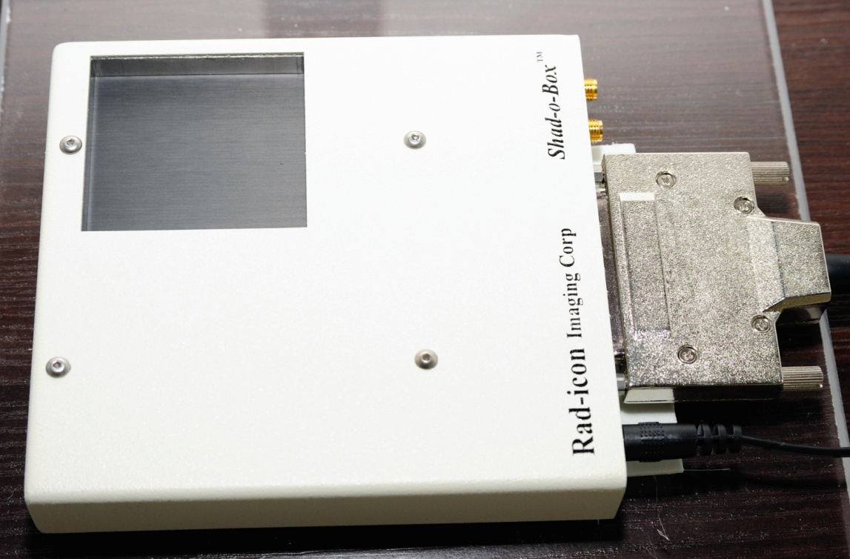 b)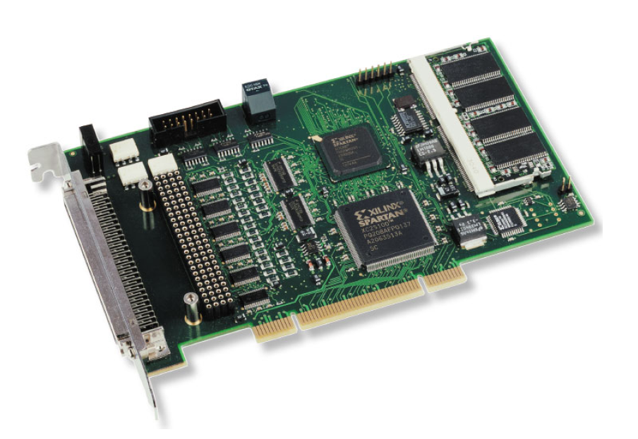

c) 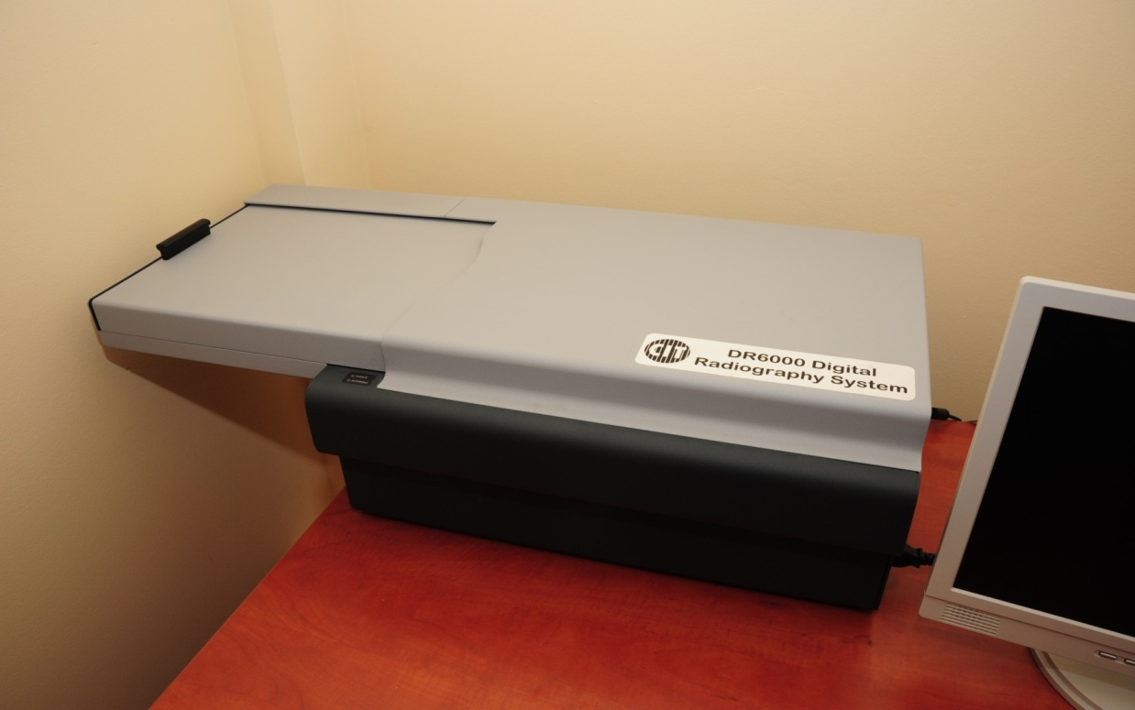

FIGURE 1. Examples of hardware used: a) Rad-Icon Shad-o-Box 1024, b) Eltec P3I3 frame grabber,
c) iCR 3600 imaging plate scanner.

GPU optimization of chosen functions

Some functions, that have a long time of computing and that can work in multithread routines, have been optimized for CUDA technology. CUDA is NVIDIA’s parallel computing architecture. It enables great increases in computing performance by harnessing the power of the GPU. Figures 2, 3 and Table 1 present comparison of results for non-CUDA and CUDA systems.

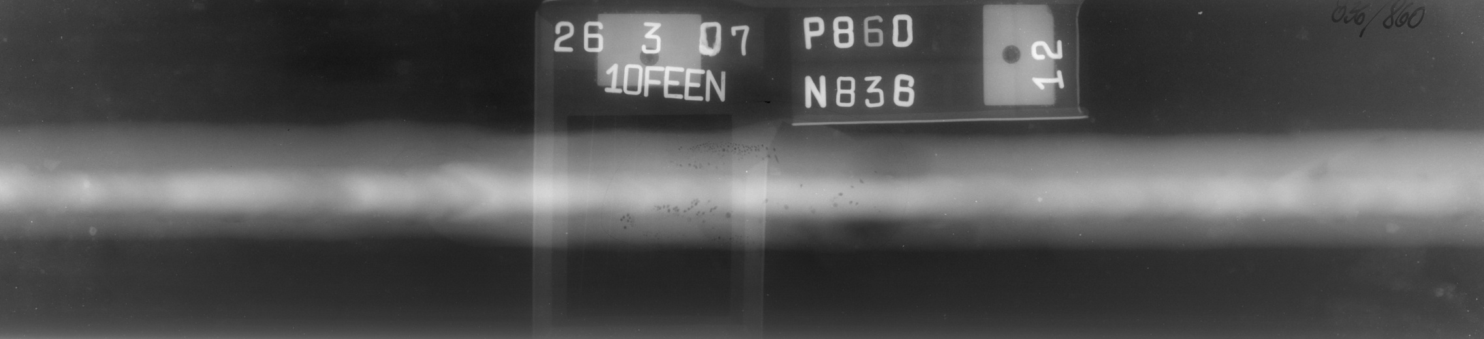

FIGURE 2. Example of a test image - 14-32-53_836A.tif scaled from 100% to 10%.

TABLE 1. Resolution of test images used for speed comparison.

Image size | Resolution | File size
100 % | 7576 x 1737 | 26319248
90 % | 6818 x 1563 | 21331732
80 % | 6061 x 1390 | 16868220
70 % | 5303 x 1216 | 12915544
60 % | 4546 x 1042 | 9492512
50 % | 3788 x 869 | 6602180
40 % | 3030 x 695 | 4230340
30 % | 2273 x 521 | 2387112
20 % | 1515 x 347 | 1070048
10 % | 758 x 174 | 282436

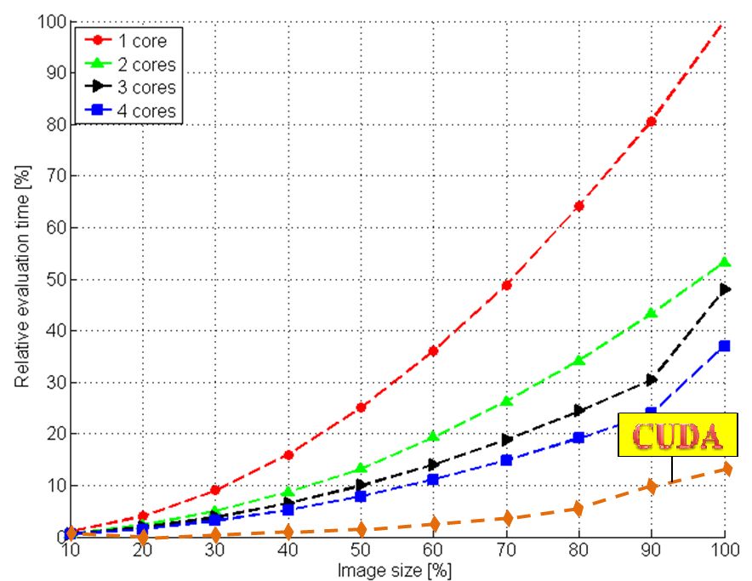

FIGURE 3. Speed comparison: Tested function - fastmedianmp – median filtering with square mask of size 71x71 pixels. Relative evaluation time versus image size (from Table 1).
SOFTWARE SIDE OF SYSTEM

A block scheme of the ISAR system is shown in Fig. 4. The software of ISAR is build of many self-contained functions written in C++ environment and integrated to create a full system. All algorithms take advantage of parallel computing for Windows x64 platform whenever it is applicable. All functions are also built as mex files, which makes it possible to test them under Matlab environment.

Image filtering algorithms

The preliminary filtering block from Fig. 4 contains linear and nonlinear filtering algorithms: high pass and low pass filters (convolve in spatial and frequency domain, with changeable mask size), Gauss, Laplace, LoG, Kirsch, Sobel, Prewitt filters [4]. Figure 5 shows examples of application of filtering functions.

Image thresholding algorithms

In our software a variety of thresholding algorithms have been implemented: local thresholding – iterative and Otsu, global tresholding – Niblack and Sauvola. Niblack tresholding computes threshold for each pixel separately, taking into account local mean and standard deviation with use of following formula [5]:

$T(i,j)=m(i,j)+k⋅σ(i,j)$(1)

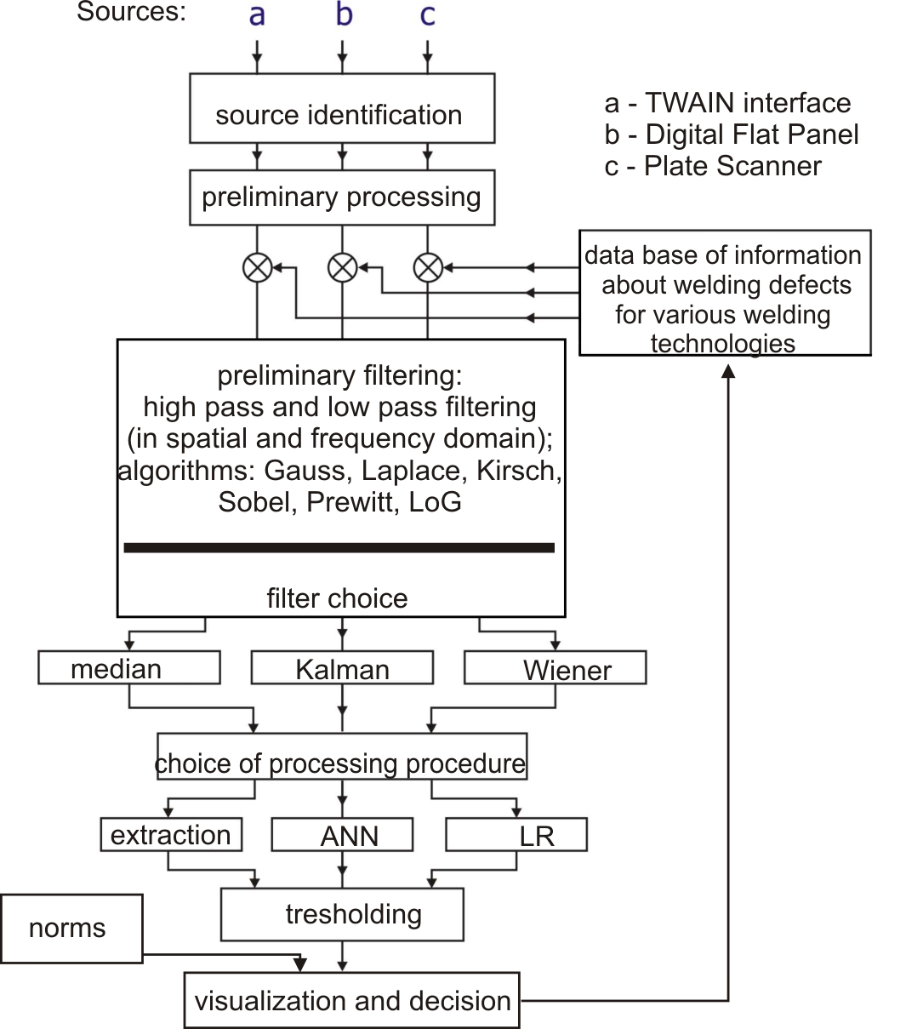

FIGURE 4. Scheme of the ISAR-system.
a)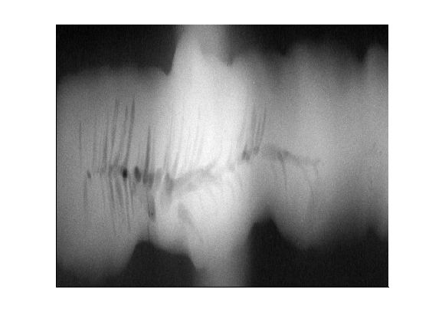 b)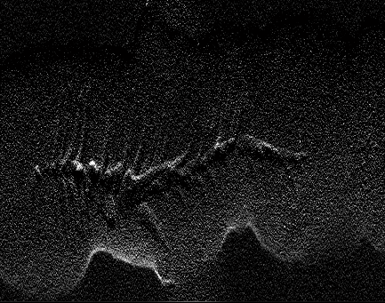 c)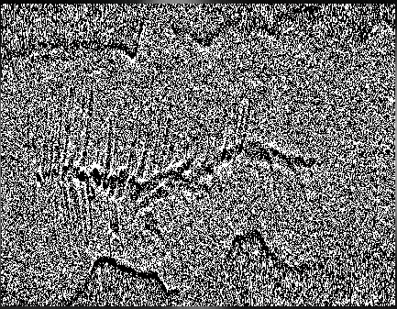

FIGURE 5. Exemplary results of X-ray weld image processing: a) original image, b) image after Kirsch filtering, c) image after HP filtering.

Sauvola thresholding is an expansion of Niblack’s thresholding, uses modified formula:
$T(i,j)=m(i,j)+\left\{1+k⋅\left[\frac{σ(i,j)}{R}−1\right]\right\}$
(2)

Figure 6 shows the results of Sauvola and Niblack’s thresholding.

Background image computation

Background images are frequently used in the digital radiogram processing to remove unwanted parts of base image and expose small objects being under investigation. They contain only low frequency component of base image. One of the possibility of creating the background image is to use a median filters with large mask. Other method is to utilize a weld profile approximation algorithm [6]. In our system both methods have been introduced. Weighted median filters can be also used for noise removal (small size of a filter mask). Figure 7 shows the exemplary results of background image computation using weld profile approximation procedure.

IQI detection

Many standards, giving advances and instructions how to take radiogram properly, have been developed and described in international norms. Preservation of standards assures good quality of radiograms as well as their repeatability and comparability even if they are taken under different conditions. Common method of measuring image quality in radiography is the use of special devices of well-known shape and parameters. Those devices are x-rayed together with the specimen and their image on the radiographic film provides significant information about quality of the radiogram. Such devices are known as Image Quality Indicators (IQIs). The quality of a radiographic image can be asserted in
a) b)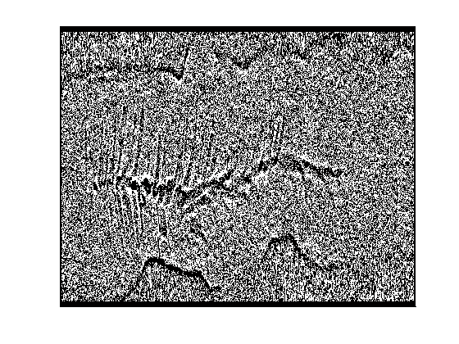 c)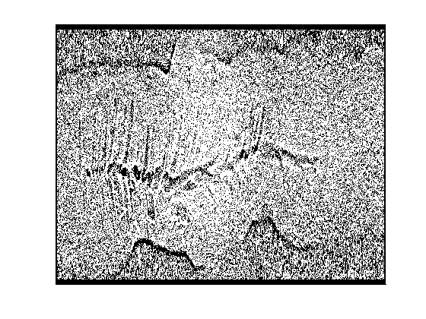

FIGURE 6. Exemplary results of X-ray weld image thresholding: a) original image, b) image after Niblack thresholding, c) image after Sauvola thresholding

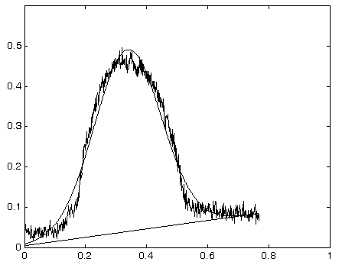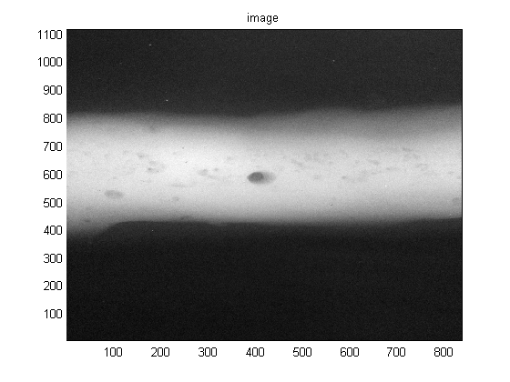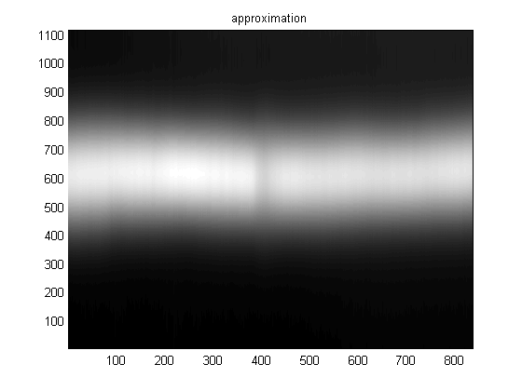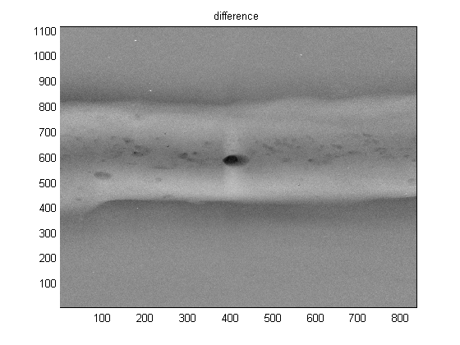
normalized position [10³ pixel]
normalized intensity
signal
approximation
linear trend
Original image
Approximated image
Difference image

FIGURE 7. Results of approximation and difference between original and approximated image.

terms of the following factors: image unsharpness (blurring), image contrast and image
noise. An IQI should be able to show changes in all these factors.
There are four types of IQI that are used in radiography - the wire, the step/hole, the hole-in-plaque and the duplex wire type. A typical wire IQI contain six or seven straight wires of the same or similar material to the specimen and having various thicknesses taken from the series: 0.10, 0.125, 0.16, 0.20, 0.25, 0.32, 0.40, 0.50, 0.63, 0.80 and 1.00 mm. The wires are held parallel to one another in plastic mount with appropriate identification symbols. These symbols are visible in x-ray picture. Typical construction details and dimensions of one exemplary design are specified in European norm EN 462 part 1:1994. The quality of the radiogram is defined basing on the visibility of the wires. The thinnest discernible wire is taken as a measure of IQI (wire) sensitivity. Generally, IQIs are very poorly visible in the real radiograms. Thereby, they require special treatment by algorithms that are robust to noise and sensitive to small changes of pixel intensity. Figure 8 shows part of real radiogram with IQIs as well as pixel intensity taken along line parallel to the wires. The process of detection of IQIs was divided into two steps. In the first stage only the presence and the position of the indicator are obtained whereas, the second step provides exact information on the position of particular wires. Thus, it is possible to evaluate the quality of the radiogram based on the visibility of wires in the wire type indicator. The position of IQI as well as the position of wires are obtained from
a fusion of two methods commonly used in the pattern recognition. These methods are: 1) measuring the dependence between sought pattern p and radiogram I using Pearson product-moment correlation coefficient and Fourier phase correlation and 2) using the Radon transform to amplify straight lines in the radiogram (wires in this case). The pattern p is generated artificially as an average calculated from dozens of intensity profiles of IQIs obtained from various radiograms. The resulting waveform can be assumed as the best representative of IQI signal that holds general features of that signal [7]. The most characteristic feature is position and shape of peaks caused by the plastic case covering the wires in IQI. It is the best visible part of the whole indicator in the radiogram as well as in the intensity profile. The correlation coefficients are calculated between the pattern p and the window of size p sliding over the radiogram I with step of 1:
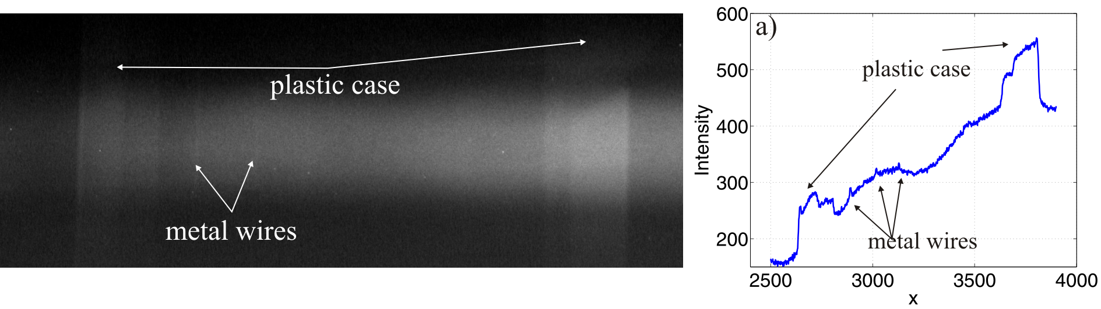
FIGURE 8. Profile of image intensity taken parallel to the wires.

(3)

where I_{i} stands for i-th position of the window in the radiogram I, n is the number of elements of p and I_{i}. The position of the maximum of function r is correlated with the position of IQI in the radiogram. In order to make the detection process more reliable the correlation function r has been verified by evaluating Fourier phase correlation as well.

SUMMARY

Functions implemented in ISAR can effectively increase the quality of X-ray radiogram and help with extracting information about welds’ defects. Presented system will be expanded in order to make automatic decision about welds quality. Full program of ISAR will have user-friendly Windows application form. User of ISAR application does not need to have an experience of all kinds of welds defects evaluion. The system allows making decision without human.

ACKNOWLEDGEMENTS

This work is supported by the Ministry of Education and Science, Poland, under grant N R01 0037 06 (2009-2012).

REFERENCES

- U. Ewert and J. Beckmann, "Theory and Demonstration on Digital Industrial Radiology and Computer Simulation" in BAM Workshop DIR-2008, Theory and Demonstration on Digital Industrial Radiology and Computer Simulation, Berlin, 2008
- Sc. Sood, Corrosion and Condition Monitoring with Digital Radiography, CIT - Computerized Information Technology LTD, Milton Keynes, United Kingdom, 2006
- www.twain.org
- W. Malina and M. Smiatacz, Metody cyfrowego przetwarzania obrazów, Akademicka Oficyna Wydawnicza EXIT, Warsaw, 2005 (in polish).
- J. Sauvola, M. Pietikainen, Pattern Recognition, vol. 33, 225- 236 (2000)
- R. Sikora, T. Chady, P. Baniukiewicz, P. Łopato, M. Caryk, K. Świadek, W. Ruciński, "Comparison of selected weld defects extraction methods" Electrical Review, vol. 11, 181-183 (2007)
- P. Baniukiewicz, R. Sikora, "Automatic Detection and Identification of Image Quality Indicators in Radiograms" in The 15th International Workshop on Electromagnetic Nondestructive Evaluation, Szczecin, 2010, IOS Press (in progress)

